---VISVESVARAYA TECHNOLOGICAL UNIVERSITY
“JnanaSangama”, Belgaum -590014, Karnataka.



LAB REPORT
on

BIG DATA ANALYTICS
(20CS6PEBDA)

Submitted by

HARSHITA M JAKA (1BM19CS058)

in partial fulfillment for the award of the degree of
BACHELOR OF ENGINEERING
in
COMPUTER SCIENCE AND ENGINEERING



B.M.S. COLLEGE OF ENGINEERING
(Autonomous Institution under VTU)
BENGALURU-560019
May-2022 to July-2022

B. M. S. College of Engineering,
Bull Temple Road, Bangalore 560019
(Affiliated To Visvesvaraya Technological University, Belgaum)
Department of Computer Science and Engineering


CERTIFICATE
This is to certify that the Lab work entitled “BIG DATA ANALYTICS” carried out by HARSHITA M JAKA(1BM19CS058), who is bonafide student of B. M. S. College of Engineering. It is in partial fulfillment for the award of Bachelor of Engineering in Computer Science and Engineering of the Visvesvaraya Technological University, Belgaum during the year 2022. The Lab report has been approved as it satisfies the academic requirements in respect of a BIG DATA ANALYTICS - (20CS6PEBDA)work prescribed for the said degree.

Name of the Lab-Incharge Dr. Jyothi S Nayak
Designation Professor and Head
Department of CSE Department of CSE
BMSCE, Bengaluru BMSCE, Bengaluru
`

Index Sheet
Sl. No. | Experiment Title | Page No.
1 | MongoDB CRUD Demonstration | 4
2 | Cassandra Employee Dtabase | 6
3 | Cassandra Library Database | 8

Course Outcome
CO1 | Apply the concept of NoSQL, Hadoop or Spark for a given task
CO2 | Analyze the Big Data and obtain insight using data analytics mechanisms.
CO3 | Design and implement Big data applications by applying NoSQL, Hadoop or Spark

- MongoDB- CRUD Demonstration

CRUD (CREATE, READ, UPDATE, DELETE) OPERATIONS
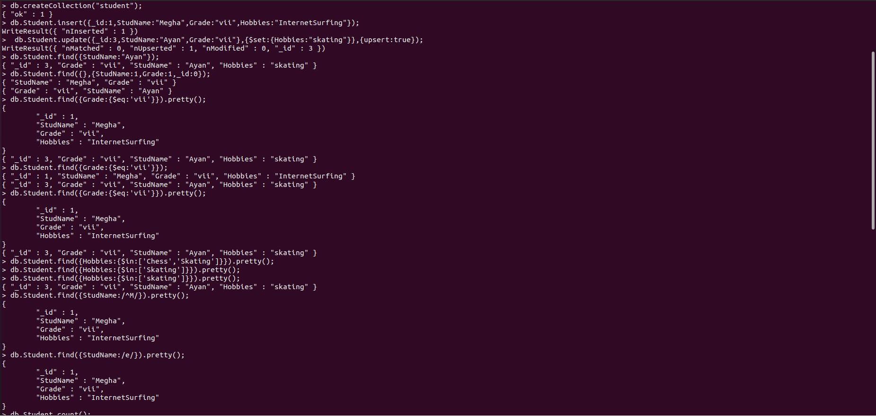

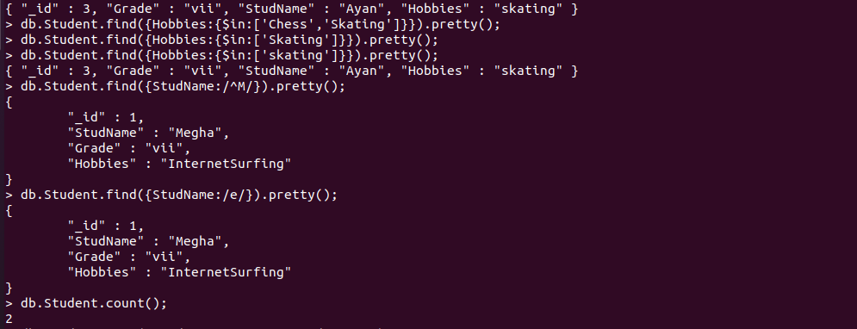

Save Method
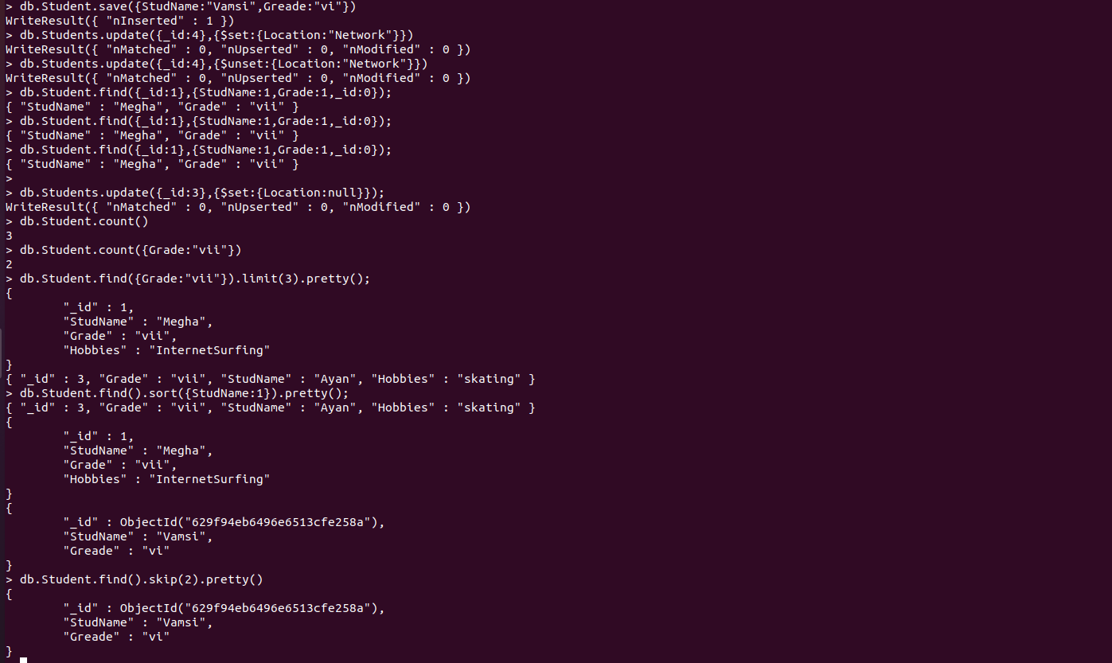

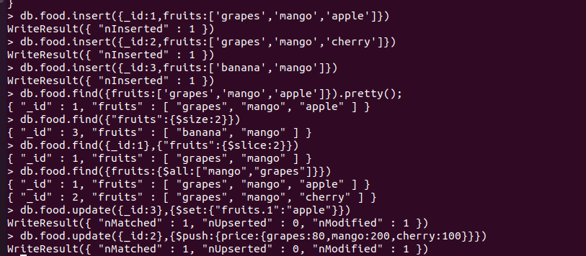

Aggregate Function
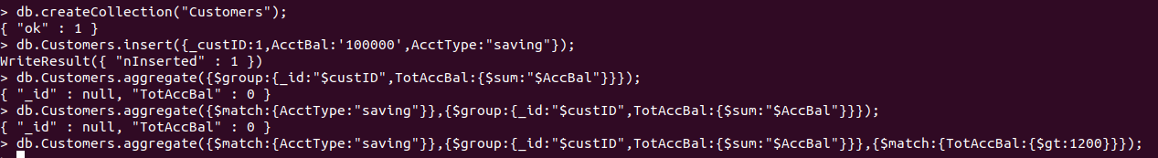

2.Perform the following DB operations using Cassandra.
1.Create a key space by name Employee

2.Create a column family by name Employee-Info with attributes Emp_Id Primary Key, Emp_Name, Designation, Date_of_Joining, Salary, Dept_Name
3.Insert the values into the table in batch

4. Update Employee name and Department of Emp-Id 2

5. Sort the details of Employee records based on salary

6. Alter the schema of the table Employee_Info to add a column Projects which stores a set of Projects done by the corresponding Employee.

7. Update the altered table to add project names.

3. Perform the following DB operations using Cassandra.
1. Create a key space by name Library

2. Create a column family by name Library-Info with attributes Stud_Id Primary Key,
Counter_value of type Counter,
Stud_Name, Book-Name, Book-Id, Date_of_issue

3. Insert the values into the table in batch

4.Display the details of the table created and increase the value of the counter

5. Write a query to show that a student with id 112 has taken a book “BDA” 2 times.

6. Export the created column to a csv file

7. Import a given csv dataset from local file system into Cassandra column family

